To What Extent Is Empowering Girls as Leaders Essential to Advancing Gender Equality in UK Education and Politics?

Farnborough Hill School
Saajana Murali, Callie Evans. Queen Mubarik, Jennifer Hughes, Millie Hughes, Anita Mirhosseini
St Mary’s School for Girls
Nancy Martin, Tilly Cooper, Sofia Maddison, Cisely Harris, Jess Leveridge, Ira Roy Kini

Introduction 1
Section 2: Literature Review 2
Case Studies of three female Prime Ministers 2
Margaret Thatcher 2
Theresa May 2
Liz Truss 3
Case studies of female educational leaders 4
Malala Yousafzai 4
Michelle Bachelet 4
Michelle Obama 4
Julia Gillard 4
Research on girls with SEN needs 4
Key differences in Boys’ and Girls’ Education 5
Effective Learning Strategies for Girls 5
Insights into Boys’ Learning 5
Single-Sex vs. Co-Education 6
Section 3: Methodology 6
Section 4: Data Analysis 6
Section 5: Evaluation 9
Section 6: Conclusion 10
References 10

Introduction
In recent years, the conversation around gender equality has gained significant momentum in the UK, yet women remain underrepresented in leadership roles—particularly in politics and senior positions in education. While educational attainment among girls often surpasses that of boys, with this year being an exception, this academic success does not consistently translate into leadership or policy influence. This disconnect raises an important question: What is preventing girls from progressing into leadership roles, and how crucial is their empowerment to the broader goal of gender equality?
We chose this research topic because of a growing personal and academic interest in gender issues, particularly as students with SEN needs, considering leadership within the UK and the roles of women who had made an impact over time. As pupils who have witnessed both the benefits and limitations placed on girls within educational settings, we were motivated to explore how early empowerment can shape long-term trajectories. Additionally, ongoing public discourse around women in politics—from gender pay gap to the treatment of female MPs—prompted us to consider how change might begin not just at the top, but through fostering leadership potential from pupils our age.
The aim of this research is to investigate the extent to which empowering girls as leaders is essential to advancing gender equality in UK education and politics.
Our main objectives:
- To evaluate current opportunities for girls to engage in leadership within UK schools and political youth initiatives.
- To examine the barriers—social, cultural, and institutional—that may prevent girls from aspiring to or achieving leadership roles – and key differences in boy’s and girls’ education.
- To analyse how female leadership, when supported and visible, contributes to changing perceptions of gender roles.
- To assess whether empowerment strategies are effectively addressing intersectional inequalities.
- Ultimately, to determine how essential this empowerment is in achieving genuine and sustainable gender equality in both education and politics.
By critically analysing these factors, this research hopes to contribute to a clearer understanding of how girl-focused leadership development can act as a catalyst—or a necessary condition—for wider societal change.

Section 2: Literature Review

Case Studies of three female Prime Ministers

Margaret Thatcher
Margaret Thatcher became Britain’s first female Prime Minister in 1979, serving for 11 years. Nicknamed the “Iron Lady,” she symbolized strength and control during a male-dominated political era.
Born in 1925 in Grantham, Thatcher studied chemistry at Oxford and later trained as a barrister. She admitted lifelong struggles with public speaking. Despite facing sexism in Parliament, she rose quickly, becoming Conservative Party leader in 1975.
At the time, only 3% of MPs were women. Though her leadership didn’t immediately increase female representation, she inspired future generations of women in politics.
Her leadership was divisive — praised for bold reforms but criticised for policies that increased inequality. Many questioned if a wife and mother could lead; Thatcher aimed to prove them wrong. She was often accused of being too “unfeminine,” but challenged the idea that only men could lead on the world stage.
Though not a feminist, Thatcher’s success reshaped British politics and proved that women could hold the highest office — and stay there.

Theresa May
Theresa May, Britain’s second female Prime Minister, served from July 2016 to July 2019. Known for her cautious but determined leadership, she played a key role during Brexit negotiations.
Educated at state and private schools, May studied Geography at Oxford, where her political ambition was clear. She participated in debating societies, student politics, and told friends she wanted to be Prime Minister — even before Margaret Thatcher took the role.
Before entering Parliament, she worked at the Bank of England. She became MP for Maidenhead in 1997 and served as Home Secretary from 2010 to 2016. She became Conservative Party leader and Prime Minister after David Cameron resigned following the Brexit referendum.
As Prime Minister, May introduced a long-term healthcare plan for the NHS and led difficult Brexit negotiations. Though she survived two leadership challenges, mounting pressure from her party led to her resignation in 2019, succeeded by Boris Johnson.
Her political career spanned decades, and she remained active in public service. While her time as Prime Minister was brief, her influence on British politics, especially as a female leader during a turbulent time, remains significant.

Liz Truss
Liz Truss served as UK Prime Minister for just 45 days in 2022, making her the shortest-serving PM in British history.
Born in 1975, Truss was raised in a left-leaning household. She studied Philosophy, Politics, and Economics at Oxford, where she was active in student politics and initially a Liberal Democrat, famously calling for the monarchy's abolition. She later joined the Conservative Party in 1996.
Before entering Parliament, she worked as an economist for Shell and Cable & Wireless. After two failed election bids, she became MP for South West Norfolk in 2010. Over the next decade, she held several cabinet roles under three Prime Ministers, including Secretary of State for Justice and International Trade.
In July 2022, she succeeded Boris Johnson as Prime Minister but faced immediate economic and political turmoil. Her mini-budget triggered market instability, leading to her resignation just weeks later.
Despite her short tenure, Truss remains a political figure through public speaking and media engagements, including a high-profile visit to Taiwan in 2023. She lost her parliamentary seat in 2024 but continues to influence politics from outside Westminster.

Case studies of female educational leaders

Malala Yousafzai
- Pakistani education activist who survived a Taliban assassination attempt at age 15.
- Advocates globally for girls' education and gave the powerful speech "I Am Malala."
- Awarded the Nobel Peace Prize in 2014 for her work in promoting girls’ learning.

Michelle Bachelet
- Former President of Chile, increased public education funding in 2014.
- Advocated for gender equality in education before her presidency.
- Her leadership shows the value of women in top political roles to advance education.

Michelle Obama
- Former First Lady of the U.S., author, and global education advocate.
- Launched the “Let Girls Learn” initiative to support girls’ education worldwide.
“Girls are our change-makers… dreamers and visionaries who could change the world.”

Julia Gillard
- Former Prime Minister of Australia, now leads the Global Partnership for Education.
- Focuses on making education accessible for girls of all economic backgrounds.
- Driven by her political platform to create lasting global impact in girls' education.
- International Women’s Day: March 8
- Lady Margaret Beaufort (mother of Henry VII) founded two colleges in medieval times.
- Girls are 35% more likely to attend university than boys (on average).
- Nearly 1 in 3 schools in East England have no female teaching staff

Research on girls with SEN needs
We found that the bias between girls and boys SEN identification is critical and needs to be studied and controlled. I found that in a survey of 10,000 primary school students, 2.29% of males had been diagnosed with some form of speech, language and communication needs, compared to 0.77% of girls. Adding to this, the proportion of girls out of all students identified with autism spectrum disorder increased from 17% to 25%. This shows that the SEN gender gap is being studied and we have uncovered this gap, but we still need to control it and start researching more recent surveys.

Key differences in Boys’ and Girls’ Education
Cognitive and Developmental Differences
- Language Development:
  - By age 3, 99% of girls’ speech is comprehensible.
  - Boys reach the same level by age 4.
- Brain Processing:
  - Girls’ brains process information more quickly and across more areas simultaneously.
  - This may offer an advantage in learning tasks.
- Emotional Processing:
  - Girls often process emotions in brain regions linked to speech and intellectual activity.
  - This may enhance verbal and emotional learning.

Effective Learning Strategies for Girls
- Role Models:
  - Positive female mentors boost confidence and career ambition.
- Representation in Curriculum:
  - Stories of successful women help girls visualize their potential and combat gender bias.
- Learning Style:
  - Girls often thrive when they understand the “why” behind subjects.
  - Hands-on experiences (e.g., internships, community service) help solidify learning.
- Mindset and Motivation:
  - Encouraging a growth mindset builds resilience and confidence.
  - Learning from mistakes becomes part of progress.
- Feedback Approach:
  - Qualitative feedback (alongside grades) reduces anxiety and supports academic development.

Insights into Boys’ Learning
- Engagement:
  - Boys may become bored or restless more easily.
  - This may stem from neurological factors like a heightened “fight or flight” response.
- Emotional Expression:
  - Boys process emotions in brain regions linked to movement.
  - This may make verbal emotional expression more difficult.

Single-Sex vs. Co-Education
- Girls in All-Girls Schools:
  - Often achieve higher exam results than girls in co-ed schools.
- Support for Co-Ed Schools:
  - Some educators argue that co-ed schools better prepare students for real-world interactions.
- Individual Needs Matter:
  - The best educational environment depends on the individual student.
  - Choice in education is essential.

Section 3: Methodology
For this project, we conducted mixed-methods research, combining both quantitative and qualitative approaches. We began with online research, using reliable sources such as education websites, blogs, academic articles, and trusted reports to build foundational knowledge. We summarised key information in our own words to ensure understanding and relevance to our topics. In addition, we created a questionnaire, distributed within the school community, to gather first-hand data. The questions focused on views about gender and education, asking things like: “Do you think boys and girls learn differently?” and “Have you ever had a female role model in school?”
We used convenience sampling, targeting a mix of students and staff who were readily available. Ethical considerations were addressed by gaining verbal consent, assuring confidentiality, and informing participants of their right to withdraw at any time. All data collected was kept anonymous to protect privacy.

Section 4: Data Analysis
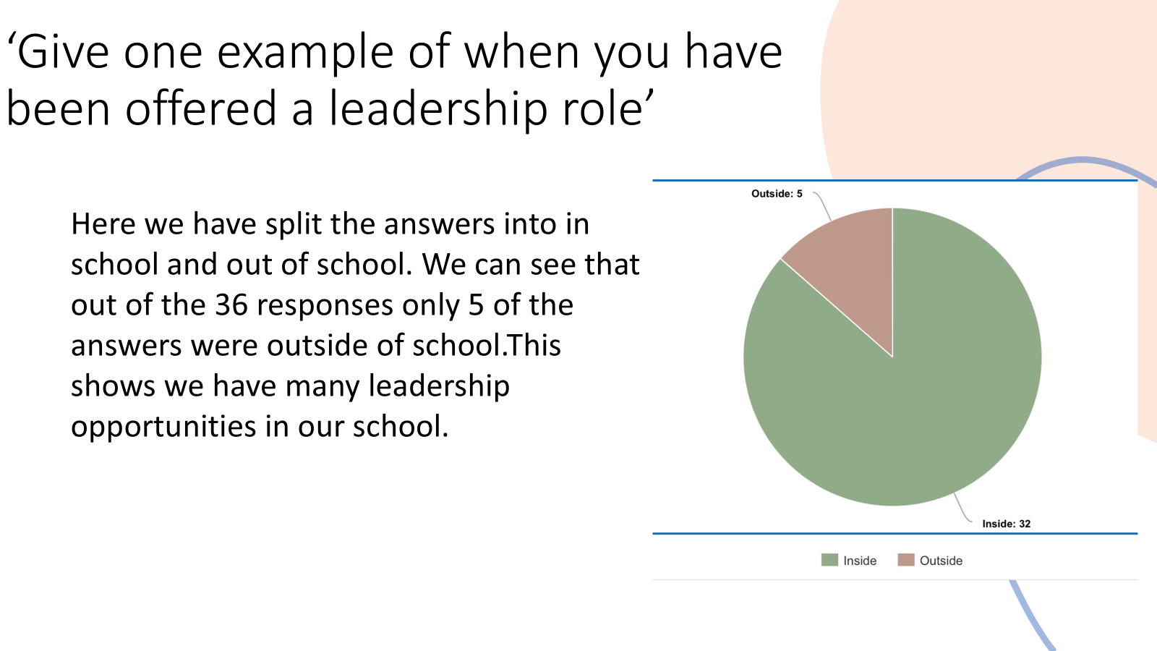
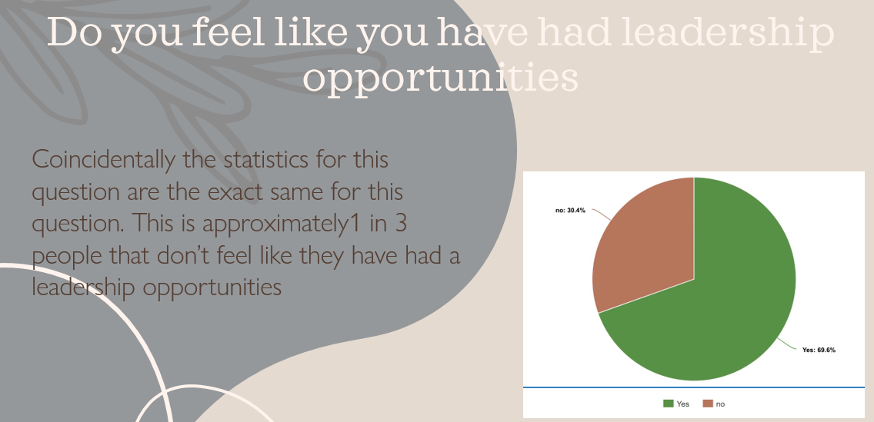
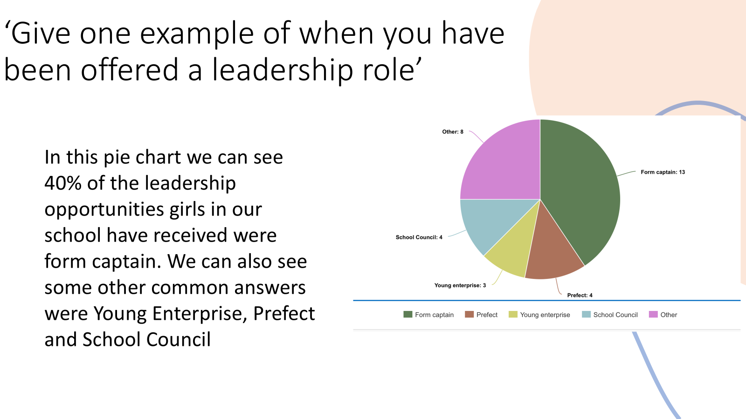
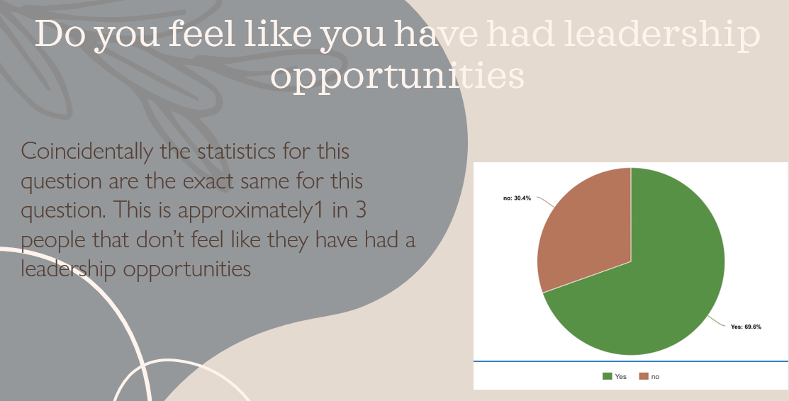
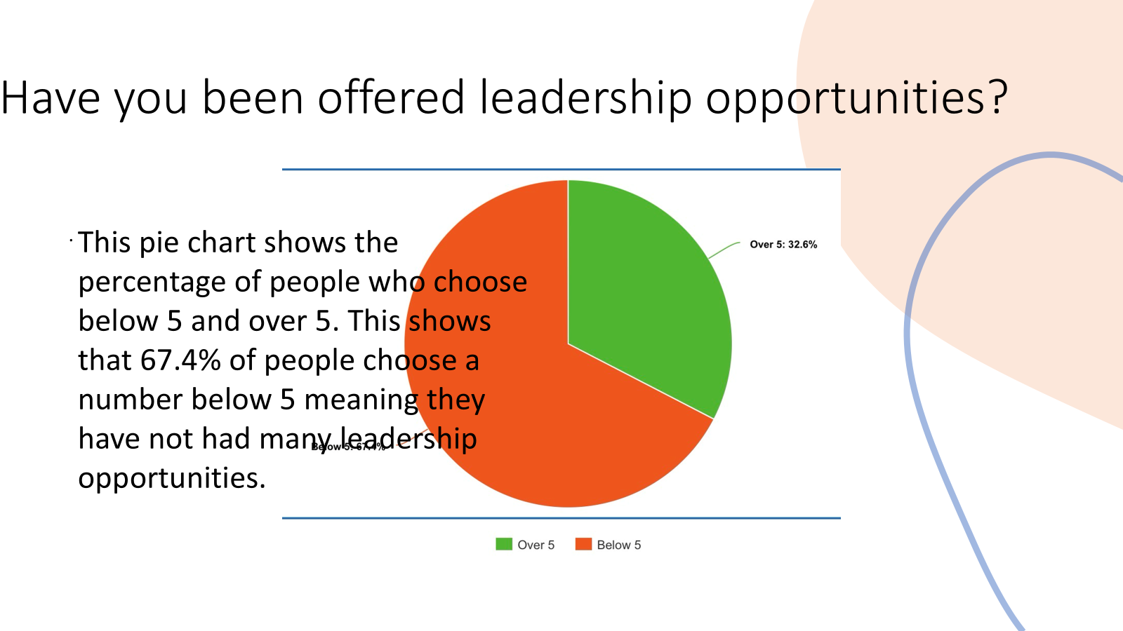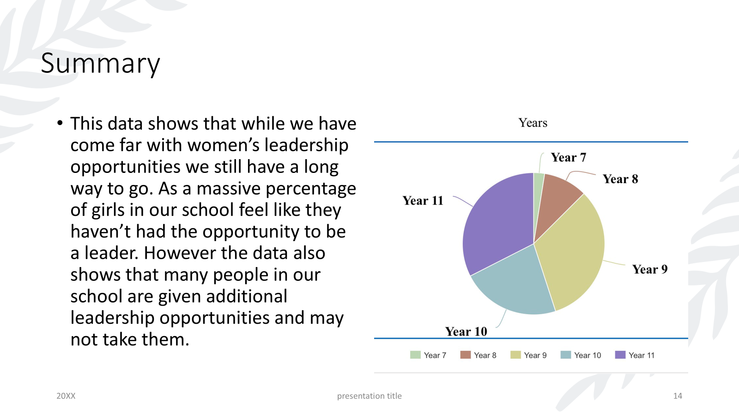

Section 5: Evaluation
The research process went well overall and allowed us to explore a wide range of sources and perspectives. We successfully gathered both primary and secondary data that aligned with our objectives, using trusted educational websites, government reports, and real-world case studies to build a solid foundation.
The internal questionnaire provided valuable, first-hand insights into current attitudes and barriers girls face in leadership roles. Organising our findings under each objective helped maintain clarity and focus.
However, we did face some challenges, such as ensuring our research reflected diverse experiences. Some online sources lacked up-to-date statistics or carried political bias, and our questionnaire had a limited response rate, which reduced the sample size.
In the future, we would aim to collect more diverse data and increase participation by using anonymous digital surveys or conducting interviews for richer insights. We also recognised the importance of better time management by setting clearer deadlines.
Through this project, we learned that combining qualitative and quantitative data provides a fuller picture of complex issues like gender inequality in education and politics. We also saw how visible, supported female leadership can challenge stereotypes and inspire others, although many barriers still exist. Most importantly, we realised that research is not just about collecting information – it is about putting that information into practice and acting on the findings. Empowering girls through education and leadership is essential for achieving genuine, lasting gender equality.

Section 6: Conclusion
Our research clearly shows that empowering girls as leaders is not just beneficial—it is essential to advancing gender equality in both UK education and politics. While girls frequently outperform boys academically, this does not automatically translate into leadership opportunities or representation at senior levels. Structural barriers, cultural expectations, and a lack of visible role models continue to hinder progress. However, our case studies and data indicate that when girls are encouraged, supported, and provided with strong female role models—both in schools and in national leadership—they are more likely to challenge stereotypes, aspire to leadership, and inspire others.
Empowerment must begin early, through inclusive educational strategies, targeted support for girls with SEN, and leadership development that reflects the diversity of girls' experiences. Only by addressing these systemic challenges can we create a society where gender equality is not an aspiration, but a reality. Therefore, empowering girls is not just part of the solution—it is a foundational step towards lasting, meaningful change.

References
Anon., 2014. CBBC - Newsround. [online] Available at: https://www.bbc.co.uk/newsround/29409738 [Accessed 13 July 2025].
Anon., n.d. The Knowledge Review - Education, Innovation, Success. [online] Available at: https://theknowledgereview.com/5-inspiring-women-leaders-who-changed-the-face-of-education/ [Accessed 2025].
BBC History, n.d. Margaret Thatcher. [online] BBC History. Available at: https://www.bbc.co.uk/history/people/margaret_thatcher [Accessed 10 Oct. 2025].
Cannadine, D., 2017. Margaret Thatcher: A Life and Legacy. Oxford: Oxford University Press.
Greenhlagh, C., 2020-21. Do Boys and Girls Learn Differently. [online] britishschoolmilan.com.
Kissinger, H., 2022. Leadership: Six Studies in World Strategy. New York: Penguin Press.
Marr, A., 2007. A History of Modern Britain. London: Pan Macmillan.
Megan Murphy, 2016. How Girls Learn Best. [online] Available at: https://girlsschools.org/advocacy/blog/2016/09/12/how-girls-learn-best/ [Accessed 5 Sept. 2025].
Murray, J., 2016. A History of Britain in 21 Women. London: Oneworld Publications.
Pankhurst, K., 2018. 100 Women Who Made History: Remarkable Women Who Shaped Our World. London: DK Publishing.
Winter, C., 2010. BBC Learning Parents Blog. [online] Available at: https://www.bbc.co.uk/blogs/parents/2010/09/do-girls-and-boys-really-need.shtml [Accessed 1 Sept. 2025].

Anon., 2014. CBBC - Newsround. [Online]
Available at: https://www.bbc.co.uk/newsround/29409738
[Accessed 13th July 2025].
Anon., n.d. the knowledge reveiw - education, innovation, success. [Online]
Available at: https://theknowledgereview.com/5-inspiring-women-leaders-who-changed-the-face-of-education/
[Accessed 2025].
Greenhlagh, C., 2020-21. Do Boys and Girls Learn Differently. s.l.:britishschoolmilan.com.
Megan Murphy, 2016. https://girlsschools.org/advocacy/blog/2016/09/12/how-girls-learn-best/. [Online]
[Accessed 5 9 2025].
Winter, C., 2010. BBC Learning Parents Blog. [Online]
Available at: https://www.bbc.co.uk/blogs/parents/2010/09/do-girls-and-boys-really-need.shtml
[Accessed 01st September 2025].
Megan Murphy, 2016. https://girlsschools.org/advocacy/blog/2016/09/12/how-girls-learn-best/. [Online]
[Accessed 5 9 2025].

